Severe Storms (Thunderstorms, Tornadoes, & Hurricanes)
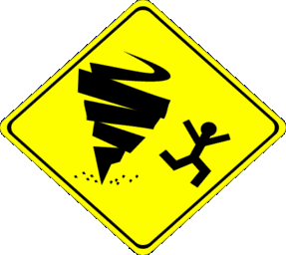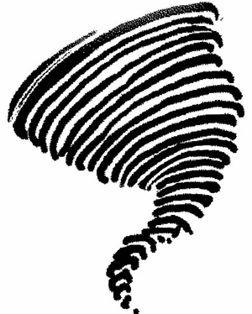Final Exam Study Guide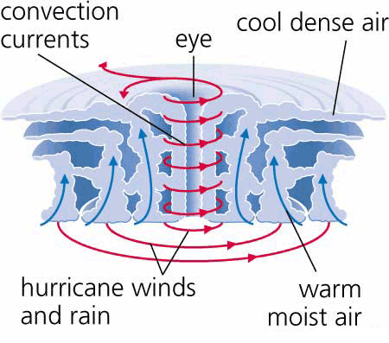
Thunderstorms
- Thunderstorm definition?
- Stages of Ordinary Thunderstorms (pg 254)
- Cumulus, Mature, & Dissipating (Diagram 10.1 – pg 254 and notes in class
- Characteristics of Stages
- Multicell Thunderstorms (as families)
- Severe Thunderstorms compared to Ordinary (Air Mass) Thunderstorms
- Floods/Flash Floods
- Lightning and Thunder – What are they? / How do they occur?
- How a lightning bolt (stroke) occurs within a Thunderstorm cloud and cloud to ground – stepped leader, return stroke
- Hail – what is it and how does it occur?
Tornadoes
- Tornadoes – What are they? How do they occur?
- Stages of Tornado Development from Dust-whirl to Decay / Characteristics
- dust-whirl
- organizing
- mature
- shrinking
- decay
- Tornado Outbreak / Where Tornadoes Occur Most and Why
- Tornado Safety - How to protect yourself in the event of a tornado
- Tornado Watches and Warnings (what’s the difference?)
- Fujita Scale ranking tornadoes in terms of wind speed/damage (Table 10.1 pg 277)
- Where tornadoes form along a Middle-Latitude Cyclonic Storm System
- Waterspouts – how are they same/different from tornadoes on land
Hurricanes
- What are they? How do they occur?
- Structure of a hurricane / Anatomy of a Hurricane (study diagram as handout in class)
- Where do they occur most? Names of other storms across world like hurricanes
- Hurricane Watches and Warnings (what’s the difference)
- Damage from Hurricane – storm surge greatest cause of destruction & death (flooding)
- Safety in Hurricane
- Saffir-Simpson Scale of Hurricanes using wind speed and damage caused (Category 1-5)
- Naming of Storms – when does a storm get its name and how does the naming system go

